|  |  |  |  |
| --- | --- | --- | --- |
|  |  |  | |
|  |  |  | |
|  |  | |
|  |  | |
|  |  | |
|  |  | |
|  |  |  | |
|  |  |  | |
|  | **USER REQUIREMENTS DOCUMENT** | |
|  |  |  | |
|  |  |  | |
|  | **CREDIT AND COLLECTIONS**  **Customer Aging Report - Commercial** |  | |
|  | Prepared for: |  | |
|  | **Rockwell Land Corporation** |  | |
|  | Project: |  | |
|  | **Dynamics 365 Finance and Operations Migration** | |
|  | Prepared by: |  | |
|  | **Creative Dynamix Solutions Inc.** |  | |
|  |  |  | |
|  | Fatima Mae Villegas  **Functional Consultant** |  | |
|  |  |  | |
|  |  |  | |
|  | Acknowledged by: |  | |
|  | **Rockwell Land Corporation** |  | |
|  |  |  | |

_________________________

|  |  |  |  |
| --- | --- | --- | --- |
| **VERSION CONTROL** | | | |
| **VERSION** | **DATE** | **DESCRIPTION OF CHANGES** | **AUTHOR** |
| 1.0 | July 29, 2022 | Initial draft | Fgv/mdc |

**TABLE OF CONTENTS**

Contents

**1 GENERAL INFORMATION** 3

**1.1** **PURPOSE** 4

**1.2** **SCOPE** 4

**2.** **CUSTOMER AGING REPORT - COMMERCIAL** 5

**3.** **FORM PRINTOUT** 7

**4.** **MAPPING** 8

**5.** **TEST SCRIPT** 12

# **1 GENERAL INFORMATION**

## **1.1 PURPOSE**

The purpose of this User Requirement Document (URD) is to provide documentation on the requirement of Rockwell Land Corporation to generate and print the Customer Aging Report.

## **1.2 SCOPE**

This User Requirement Document will outline the functional and technical design of the proposed customization as identified during the business process review (BPR).

The Customer Aging Report is used by Rockwell to monitor the balances that are due from their customers for specified periods of time. The report will help users to organize, track and manage the Rockwell’s receivables and collections. That way, users can identify invoices that are open and allows them to keep on top of slow paying clients. In addition, they can also identify the average age of receivables and identify potential losses from clients regularly. This can also help in handling the company’s cash flow, and as well in planning future and business budget.

# **CUSTOMER AGING REPORT - COMMERCIAL**

The report will be available under Credit and Collections > Inquiries and reports > Customized Reports > Customer Aging Report - Commercial. Upon click, a query criteria dialog with the same name will be displayed where the user can enter criteria to be included in the report.

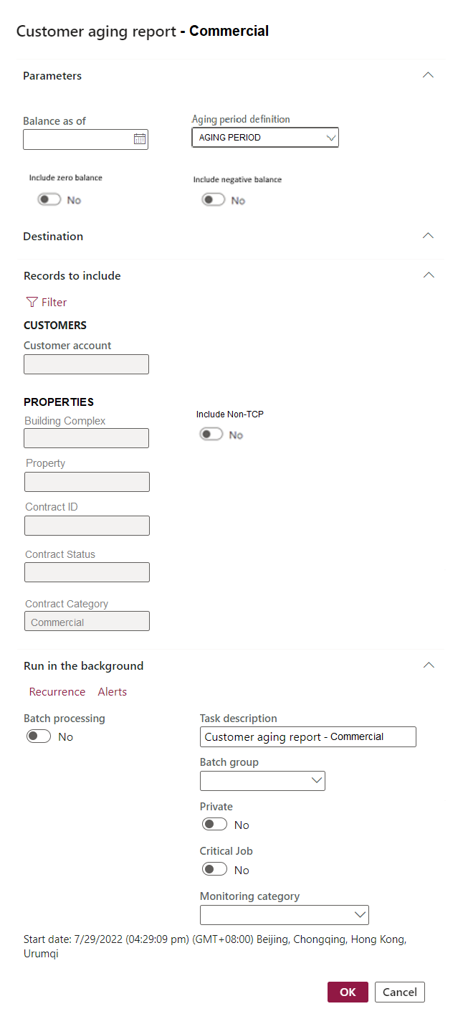

*Sample screen of query criteria window*

This query window/dialog enables the user to generate the report in real time, or via batch processing (as shown above).

*Note: If the filter button under “Records to include” is selected, a query form will be shown.*

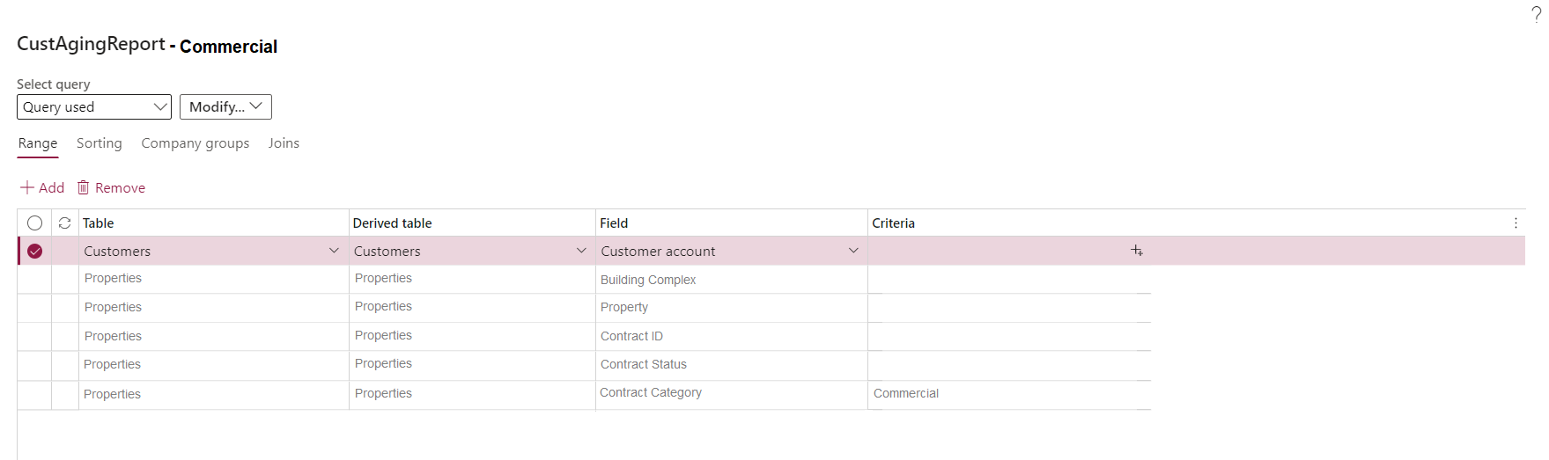

The following field parameters/criteria are available for user selection, all filters capable for multiple selection:

|  |  |  |  |  |  |
| --- | --- | --- | --- | --- | --- |
|  | **Field label name** | **Data type** | **Default value** | **Source Path** | **Comments** |
| 1 | Balance as of | Date | Blank | Will retrieve data from customer transactions based on transaction date.  Accounts receivable > Customers > All customers > Transactions > Date | User-input.  Enter the date to view the customer-contract balances for. This is also known as a cutoff date for transactions. |
| 2 | Aging period definition | Text | Aging Period Default format | Credit and Collections > Setup > Aging period definitions > Aging period definition  There should be a default aging period definition, but the user can manually override the default aging period definition.  Note: Ask Rockwell for the name of the aging period definition that will appear as default. | Display Aging period definition and Description in lookup |
| 3 | Include Zero balance | Check box/Toggle | No | Accounts receivable > Customers > All customers > Select customer > Customer tab > Transactions in the action pane > Sum of customer balance per contract id with zero balance.  If the toggle is set to Yes, transactions even with zero balances per contract ID will be displayed in the report. | Select this check box to include customer accounts that have a zero balance. |
| 4 | Include Negative balance | Check box/Toggle | No | Accounts receivable > Customers > All customers > Select customer > Customer tab > Transactions in the action pane > Sum of customer balance per contract id with negative balance.  If the toggle is set to Yes, transactions with negative balances will be displayed in the report. | Select this check box to include customer accounts that have negative balances. |
| 5 | Customer account | Text | Blank | Accounts receivable > Customers > All customers > Account  Note: Allow multiple selection | Display Customer account and Customer name in lookup |
| 6 | Building Complex (right click to view some hidden menu items) | Text | Blank | Accounts receivable > Customers > All customers > Transactions > Contract ID > View details > Property > View details > Property in the action pane > Header in the action pane > General fast tab > Building complexes  Note: Allow multiple selection | Display Building complexes value and Description in lookup |
| 7 | Property | Text | Blank | Accounts receivable > Customers > All customers > Transactions > Contract ID > View details > Property  Note: Selection of Property will be limited to selected Building complex  Note: Allow multiple selection | Display Property value and Description in lookup. |
| 8 | Contract id | Text | Blank | Accounts receivable > Customers > All customers > Transactions > Contract ID  Note: Selection of Contract ID will be limited to selected Building complex and Property  Note: Allow multiple selection | Display Contract Id, Property, Tenant, and Tenant name in lookup |
| 9 | Contract Status/Contract Sub Status | Text | Active/Active | Property Management> Contract Setup> Contract > Contract statuses | Display Contract Status value and Description in lookup. |
| 10 | Contract Category | Text | Commercial | Property Management > Contract Setup > Contract Categories > Contract types > Contract Category = Commercial | Display Contract Category in lookup. |
| 11 | Include Non-TCP | Check box/Toggle | No | If include Non-TCP is selected, Accounts receivable > Customers > All customers > Transactions > Billing type and billing classification will be included  Note: This check box will be greyed out/disabled if the contract category is Commercial. This is only applicable for Condo Sales. | Select this checkbox to include customer transactions with billing type, and billing classification. |

Data for the report will be retrieved from Customer transactions: Customer invoice journal (includes Sales lines, Lease lines, Free-text invoices and General Journal) and Customer payment journal in the system.

# **FORM PRINTOUT**

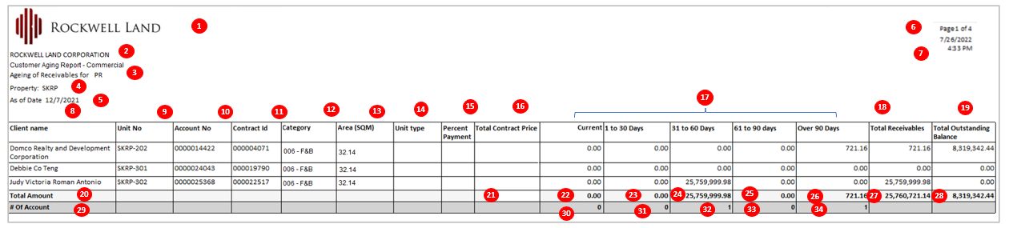

Note: Sorting will be based on Customer Name – Ascending.

Below is the mapping of the numbers in the diagram above and what is the representations of these red numbers

# **MAPPING**

|  |  |  |
| --- | --- | --- |
| Field | | **Path: Credit and Collections > Inquiries and reports > Customized Reports > Customer Aging Report - Commercial**  **Note: Group per contract ID and Unit no. sorted by customer name in ascending order.**  **Option to save the report in Excel format; No merging of cells Note:** Development of this report is thru SSRS |
| PAPER SIZE: | | Letter | |
| ORIENTATION: | | Landscape | |
| 1 | Logo | Organization administration > Organization > Legal entities > Report company logo image fast tab | |
| 2 | Company name | Organization administration > Organization > Legal entities > Name | |
| 3 | Report name | Fixed text “Customer Aging Report – Commercial” + Fixed text “Aging of Receivables for” + Credit and Collections > Inquiries and reports > Customized Reports > Customer Aging Report - Commercial > Records to include > Query criteria dialog > Building complexes If none is selected, input “All”.  Concatenate values and add space in between | |
| 4 | Property | Credit and Collections > Inquiries and reports > Customized Reports > Customer Aging Report – Commercial > Records to include > Query criteria dialog > Property | |
| 5 | As of Date | Credit and Collections > Inquiries and reports > Customized Reports > Customer Aging Report > Query criteria dialog > Balance as of | |
| 6 | Page count | Page 1 of 1 | |
| 7 | Date and time generated | Display date and time when report was generated. | |
| 8 | Client name | Accounts receivable > Customers > All customers > Select customer > Name | |
| 9 | Unit No | Accounts receivable > Customers > All customers > Select customer > Customer tab > Transactions in the action pane > Contract ID > Right click view details > Contract fast tab > Property Unit | |
| 10 | Account No | Accounts receivable > Customers > All customers > Account | |
| 11 | Contract ID | Accounts receivable > Customers > All customers > Select customer > Customer tab > Transactions in the action pane > Contract ID | |
| 12 | Category | Accounts receivable > Customers > All customers > Select customer > Sales demographics fast tab > Category (segment is the standard D365 field) | |
| 13 | Area (SQM) | Accounts receivable > Customers > All customers > Select customer > Customer tab > Transactions in the action pane > Contract ID > Right click view details > Contract fast tab > select Property Unit > General fast tab > NLA | |
| 14 | Unit type | Blank | |
| 15 | Percent Payment | Blank | |
| 16 | Total Contract Price | Blank | |
| 17 | Aging Buckets | **Header:** Credit and Collections > Inquiries and reports > Customized Reports > Customer Aging Report – Commercial > Query criteria dialog > Get Aging period definition selected > Go to Credit and Collections > Setup > Aging period definitions > Find the Aging period definition selected > Period. There will be a default aging period definition but can be overridden by the user.  Default aging:  **Data:** Accounts receivable > Customers > All customers > Select customer > Customer tab > Transactions > Sum of the Balance per Contract id.  **Current** = Includes transactions whose due date or transaction date are the same as the aging date or date after the aging date.  Note: If there is no due date, consider transaction date  **1 to 30 Days** = Includes transactions whose due date or transaction date are 1 to 30 days before the aging date. Note that the interval is -30, which starts with the first day before the subsequent aging period.  Note: If there is no due date, consider transaction date  **31 to 60 Days** = Includes transactions whose due date or transaction date are 31 to 60 days before the aging date/due date. Note that the interval is -30, which starts with the first day before the subsequent aging period.  Note: If there is no due date, consider transaction date  **61 to 90 Days** = Includes transactions whose due date or transaction date are 61 to 90 days before the aging date. Note that the interval is -30, which starts with the first day before the subsequent aging period.  Note: If there is no due date, consider transaction date  **Over 90 Days** = Includes transactions whose due date or transaction date are more than 90 days before the aging date. The ending date is the last day of the last fiscal year that is created in the Fiscal calendars form, for the fiscal calendar that is used with the transaction.  Note: If there is no due date, consider transaction date  **Note:** If aging period definition selected is different from the default or was overridden, the header and data will be based on the setup of the following: 1. Period (name of the field),  2. Unit (number of interval), and 3. Interval (days, weeks, months etc.)  If aging period definition is overridden, the corresponding aging buckets name will also change based on the setup of aging period definition.  Aging period definition setup is under Credit and collection > Setup > Aging period definition | |
| 18 | Total Receivables | Sum of All Aging Buckets = Current+1 to 30 Days+31 to 60 Days+ 61 to 90 Days+ Over 90 Days  Note: If aging period definition selected is different from the default or was overridden, sum of all aging buckets = sum of all period names. | |
| 19 | Total Outstanding Balance | Sum of All Aging Buckets excluding Current = 1 to 30 Days+ 61 to 90 Days+ Over 90 Days  Note: If aging period definition selected is different from the default or was overridden, sum of all aging buckets excluding Current = sum of all period names except period with 0 unit. | |
| 20 | Total Amount | Fixed text “Total Amount” | |
| 21 | Total Amount – Total Contract Price | Blank | |
| 22 | Total Amount – Current | Sum of column Aging buckets - Current  Note: If aging period definition selected is different from the default or was overridden, sum of all aging buckets – 1st level = sum of the period with 0 unit. | |
| 23 | Total Amount – 1 to 30 Days | Sum of column Aging buckets -1 to 30 Days Note: If aging period definition selected is different from the default or was overridden, sum of all aging buckets – 2nd level = sum of the period 2nd level next to 1st level period. | |
| 24 | Total Amount – 31 to 60 Days | Sum of column Aging buckets - 31 to 60 Days  Note: If aging period definition selected is different from the default or was overridden, sum of all aging buckets – 3rd level = sum of the period 3rd level next to 2nd level period. | |
| 25 | Total Amount – 61 to 90 days | Sum of column Aging buckets - 61 to 90 days Note: If aging period definition selected is different from the default or was overridden, sum of all aging buckets – 4th level = sum of the period 4th level next to 3rd level period. | |
| 26 | Total Amount – Over 90 days | Sum of column Aging buckets - Over 90 days Note: If aging period definition selected is different from the default or was overridden, sum of all aging buckets – 5th level = sum of the period 5th level next to 4th level period. | |
| 27 | Total Amount – Total Receivables | Sum of column Total Receivables (18) | |
| 28 | Total Amount – Total Outstanding Balance | Sum of column Total Outstanding Balance (19) | |
| 29 | # Of Account | Fixed text “# Of Account” | |
| 30 | # Of Account - Current | Count the number of customer accounts falls on Aging buckets – Current or 1st level (if aging period definition selected is different from the default or was overridden).  Note: Excluding customer account with zero amount  # of Account will also change based on the setup of aging period definition selected | |
| 31 | # Of Account - 1 to 30 Days | Count the number of customer accounts falls on Aging buckets - 1 to 30 Days or 2nd level (if aging period definition selected is different from the default or was overridden).  Note: Excluding customer account with zero amount | |
| 32 | # Of Account - 31 to 60 Days | Count the number of customer accounts falls on Aging buckets - 31 to 60 Days or 3rd level (if aging period definition selected is different from the default or was overridden).  Note: Excluding customer account with zero amount  # of Account will also change based on the setup of aging period definition selected | |
| 33 | # Of Account - 61 to 90 days | Count the number of customer accounts falls on Aging buckets - 61 to 90 days or 4th level (if aging period definition selected is different from the default or was overridden).  Note: Excluding customer account with zero amount  # of Account will also change based on the setup of aging period definition selected | |
| 34 | # Of Account - Over 90 days | Count the number of customer accounts falls on Aging buckets - Over 90 days or 5th level (if aging period definition selected is different from the default or was overridden).  Note: Excluding customer account with zero amount  # of Account will also change based on the setup of aging period definition selected | |
| 35 | Activity Phase | Accounts receivable > Customers > All customers > Select customer > Customer tab > Transactions in the action pane > Contract ID > Contract Form>Manage in the action pane >Activities in the action pane >View Activities  Show only the Phase with Activity equals to Account Status and Status is equal to Open  Set this field after the Total Outstanding Balance. | |
| 36 | Activity Type | Accounts receivable > Customers > All customers > Select customer > Customer tab > Transactions in the action pane > Contract ID > Contract Form>Manage in the action pane >Activities in the action pane >View Activities  Show only the Activity type of the Activity Phase  Set this field after the Activity Phase | |

# **TEST SCRIPT**

1. Generate the report
2. Go to Credit and Collections > Inquiries and reports > Customized Reports > Customer Aging Report - Commercial.
3. Complete details in parameters: Balance As of and Aging period definition.
4. Select toggle to include zero balance and include negative balance.
5. Select specific Building Complexes, Property, Contract ID, and Contract Status.

Note: Contract category will be defaulted as Commercial

1. If none is selected, then all data will populate.